Chapter 8: Facing Slavery – Study Guide

**Vocabulary**

|  |  |  |
| --- | --- | --- |
| Slave Trade | Dilemma | Middle Passage |
| Slave Auctions | Overseer | Triangular Trade |

**Concepts**

* West Africa
  + West African culture in the 1500s
  + Dilemmas and Choices of the Slave Trade
* The Middle Passage
  + Dilemmas and Choices in the Middle Passage
  + Living conditions on the ships
  + Locate the Middle Passage on the map
* The Colonies and North America
  + Role of slaves in West Indies and North America
  + Scrambles vs. Slave Auctions
  + Roles of workers on plantations
  + Dilemmas and Choices in the Colonies
* 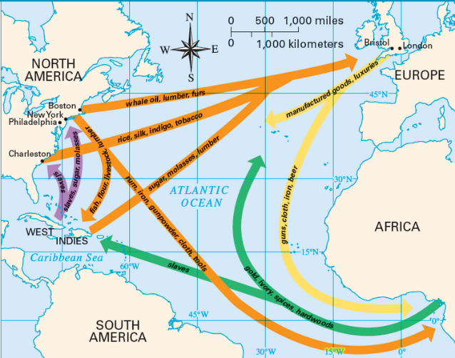Triangular Trade
  + Identify the pattern
  + Describe the trading relationship between Great Britain, Africa, West Indies, and North America

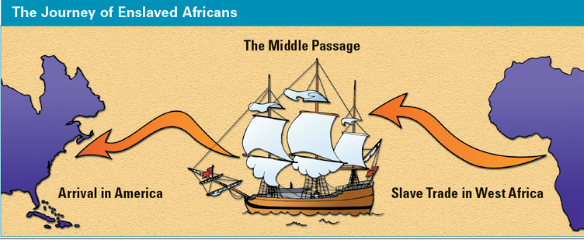**Text Features**