Hello Kindergarten Friends,

The time is coming soon for us to meet and I just can’t wait to see you!

We are going to have a great time together. We will sing songs, read stories, make projects, and learn so many wonderful new things. Of course there will be lots of other new friends who will be waiting to play and learn with you, too.

Our classroom will have many exciting things to do and see once we get started! I know that the fun will not begin until you are here, so I will be waiting for you to arrive to begin a super Kindergarten year!

Enjoy the rest of your summer. See you soon!

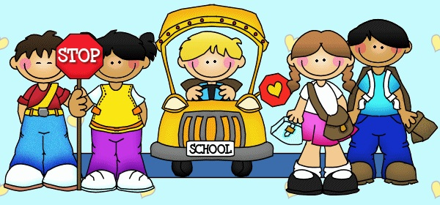

Warmly,

Mrs. Gillen

\*Give a cheer for a great new year! Please plan on attending our Kindergarten Kick-off on Wednesday, August 21st . Please bring your supplies.