Using your Lexile Score to help you find a book

Step 1: Go to Destiny Library Catalog

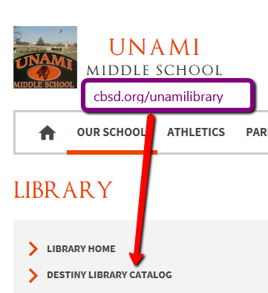

Step 2: LOGIN to the Catalog

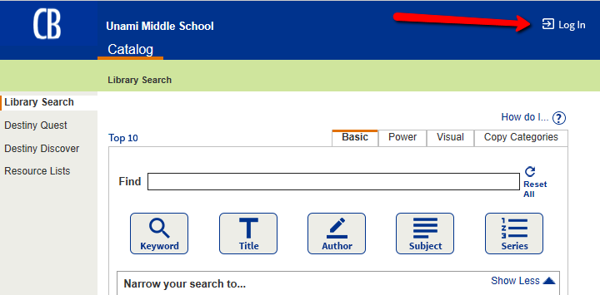

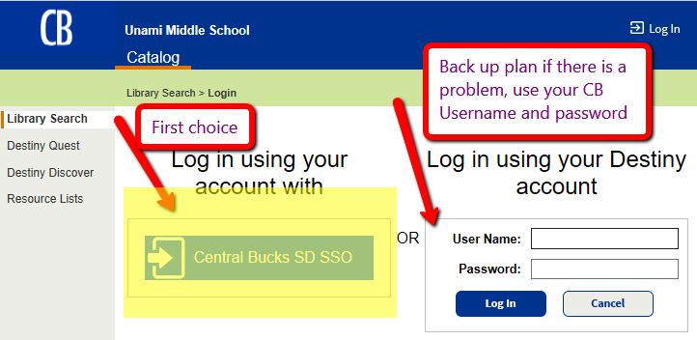

Step 3: Do a keyword/subject matter search combined with a Lexile range search.

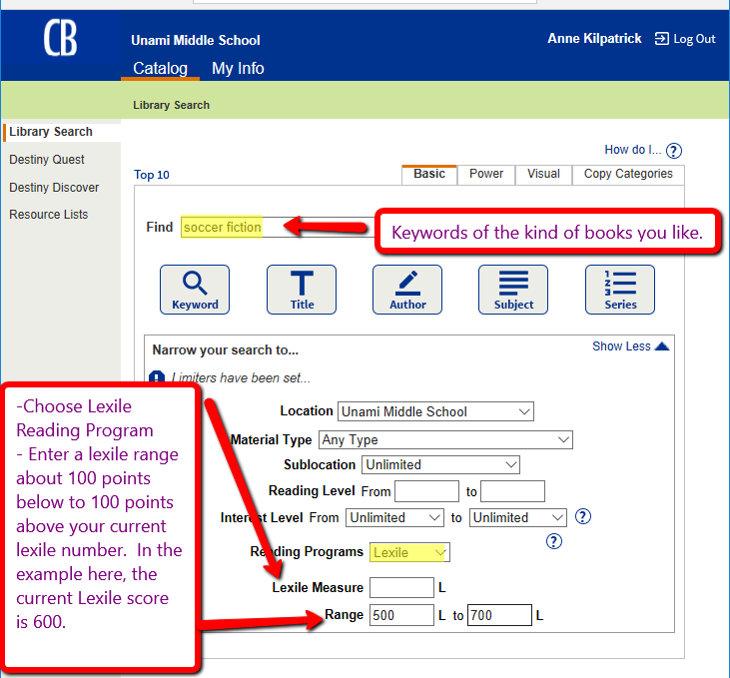

Step 4: Explore the results

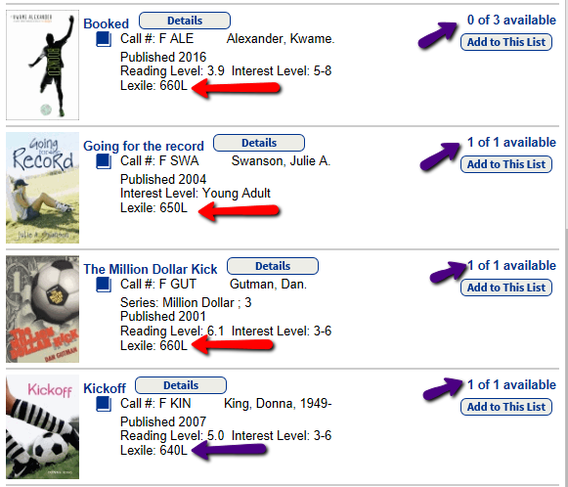

Step 5: Pick a book or two for now and add others you may like to your NEXT LIST in Destiny

